**Event Management System**



**Submitted By Submitted To**

**Rifat Hossain Rumman Ahmed Prodhan  
Roll: 42230200824  
  
Jisad kamal  
Roll: 42230200825**

**Appendix**

| **No.** | **Topic Name** | **Page No.** |
| --- | --- | --- |
| **1** | **Information of the Database** | **3-4** |
| **2** | **ER Diagram of the Database** | **5** |
| **3** | **Schema Diagram of the Database** | **6** |
| **4** | **Insert data into tables** | **7-9** |
| **5** | **Running Query** | **10-16** |

**Event Management System**

The Event Management System is a comprehensive platform designed to facilitate the planning, organization, and execution of various events. Whether it's a conference, seminar, workshop, or any other gathering, this system streamlines the entire event lifecycle, from initial planning to post-event analysis. Key features include event creation, attendee management, session scheduling, speaker coordination, and registration tracking.

***\*\*\* Tables in the Event Management System:***

**1. Events:**

Stores information about individual events, including event name, description, dates, location, and organizer details.

**2. Users:**

Manages user profiles, authentication credentials, and contact information for both organizers and attendees.

**3. Attendees:**

Tracks attendee registrations for specific events, linking attendees to their respective events and user profiles.

**4. Organizers:**

Contains details of event organizers, associating them with user accounts and providing additional organizer-specific information.

**5. Sessions:**

Organizes event activities into sessions, each with its own name, description, schedule, location, and associated speakers.

**6. Speakers:**

Stores information about speakers or presenters participating in event sessions, including their bio and contact details.

**7. Registrations:**

Tracks attendee registrations for individual sessions within events, recording registration dates and status.

***\*\*\* The information which are going to be available in the database are given below:***

**Table:** Registrations

**Attributes:**

* registration_id (Primary Key)
* event_id (Foreign Key referencing Events(event_id))
* attendee_id (Foreign Key referencing Attendees(attendee_id))
* registration_date
* registration_status

**Relations:**

* Registrations - event_id - Events
* Registrations - attendee_id - Attendees

**Table:** Speakers

**Attributes:**

* speaker_id (Primary Key)
* user_id (Foreign Key referencing Users(user_id))
* bio
* contact_information

**Relations:**

* Speakers - user_id - Users

**Table:** Sessions

**Attributes:**

* session_id (Primary Key)
* event_id (Foreign Key referencing Events(event_id))
* session_name
* start_time
* end_time
* location
* speaker_id (Foreign Key referencing Speakers(speaker_id))

**Relations:**

* Sessions - event_id - Events
* Sessions - speaker_id - Speakers

**Table:** Organizers

**Attributes:**

* organizer_id (Primary Key)
* user_id (Foreign Key referencing Users(user_id))

**Relations:**

* Organizers - user_id - Users

**Table:** Attendees

**Attributes:**

* attendee_id (Primary Key)
* event_id (Foreign Key referencing Events(event_id))
* user_id (Foreign Key referencing Users(user_id))

**Relations:**

* Attendees - event_id - Events
* Attendees - user_id - Users

**Table:** Users

**Attributes:**

* user_id (Primary Key)
* username
* password
* email
* full_name

**Table:** Events

**Attributes:**

* event_id (Primary Key)
* event_name
* event_description
* start_date
* end_date
* location
* organizer_id (Foreign Key referencing Organizers(organizer_id))

**Relations:**

* Events - organizer_id - Organizers

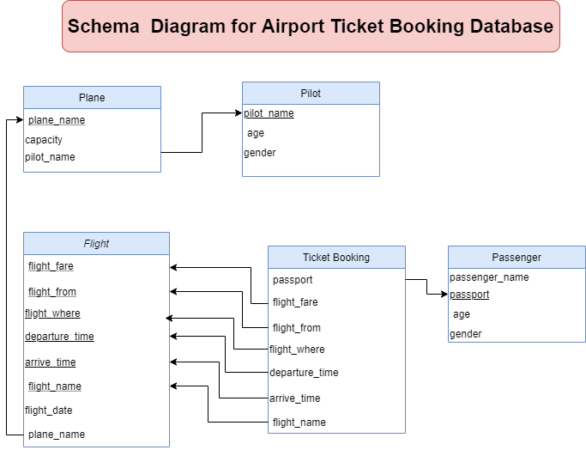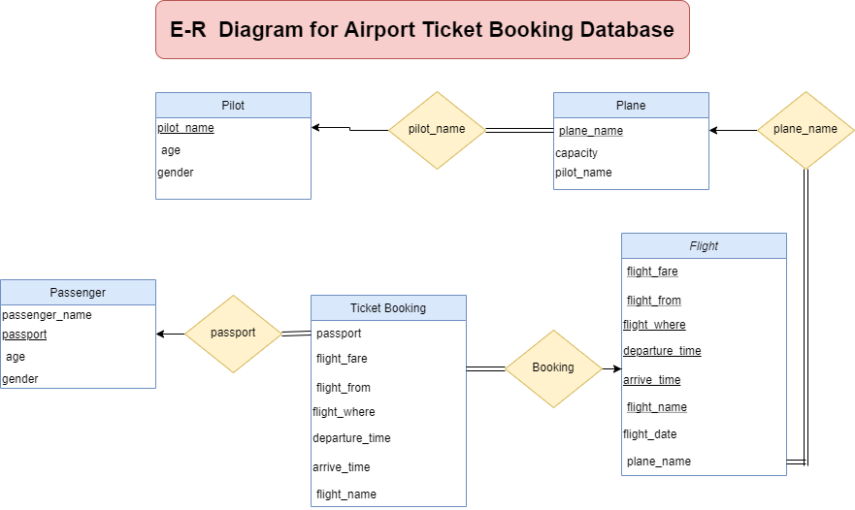

**Insert data into tables:**

**Table: Pilot**

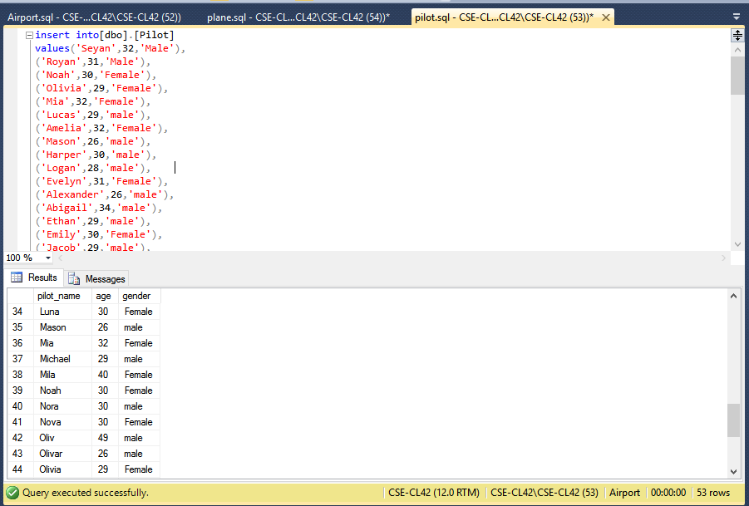

**Table: Plane**

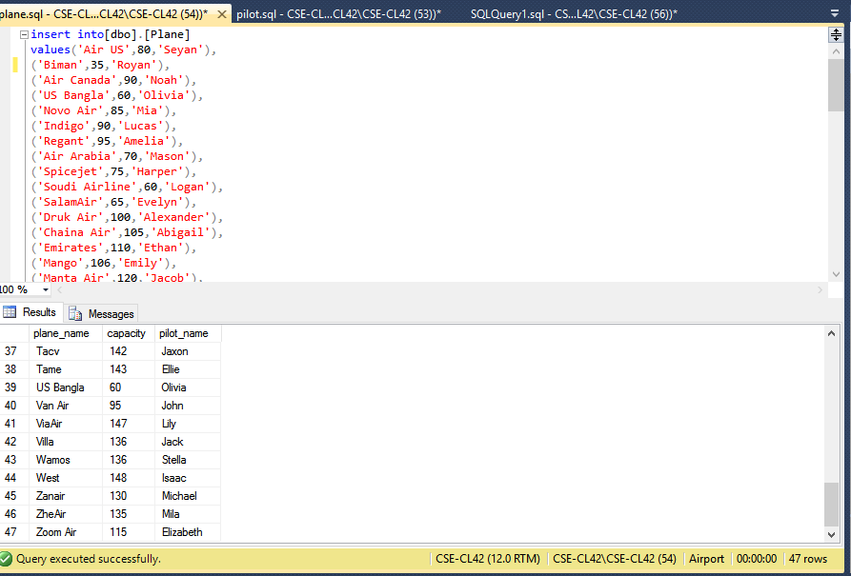

**Table: Passenger**

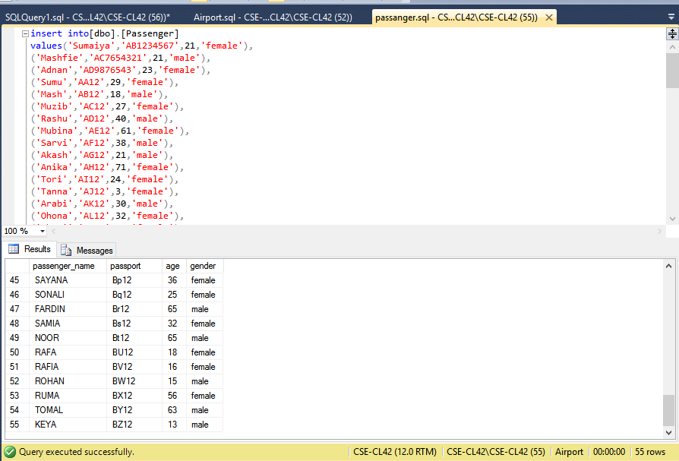

**Table: Flight**

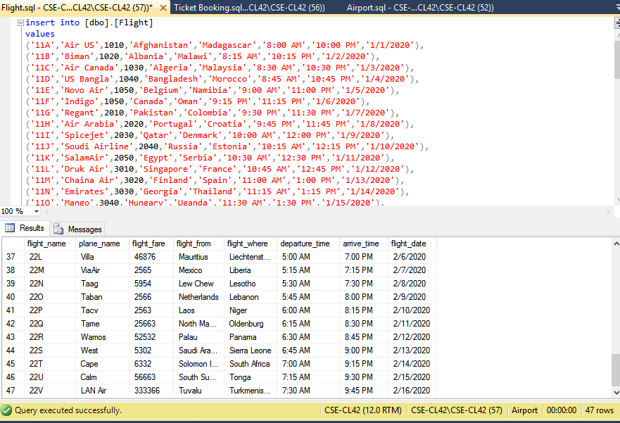

**Table: Ticket Booking**

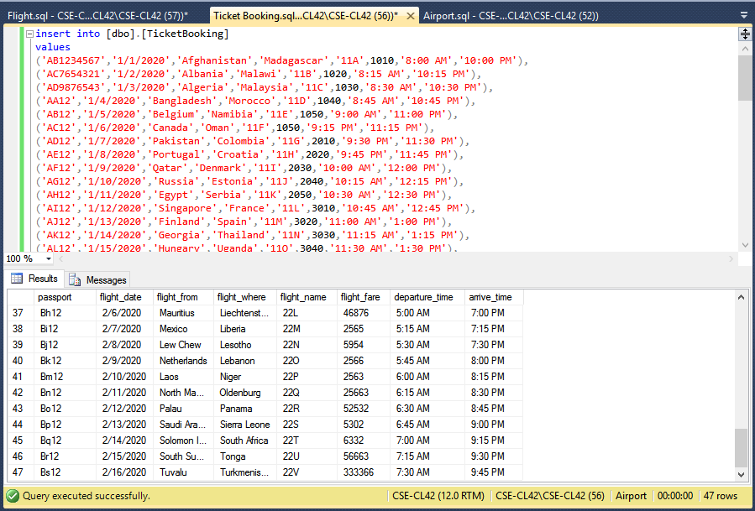

**Running Query:**

1. **Find the names of all passengers**

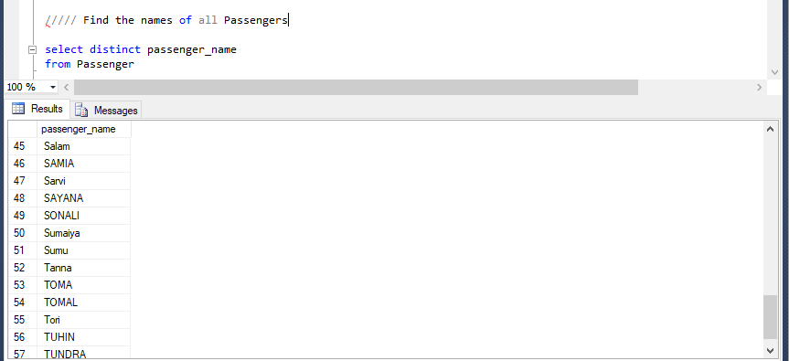

1. **An asterisk in the select clause denotes to “all attributes”**

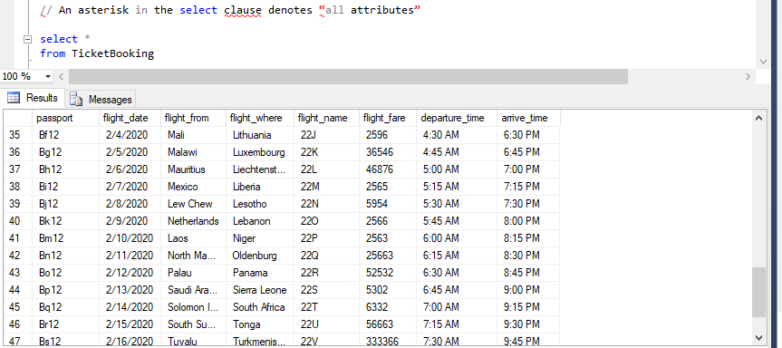

1. **To find all Flight Date from “Bangladesh” to “Morocco”**

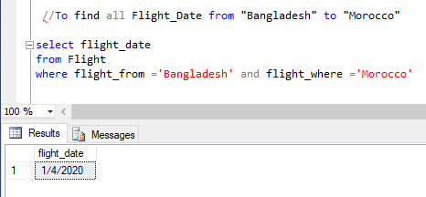

1. **Find the names of all Pilot who is under 30 years old**

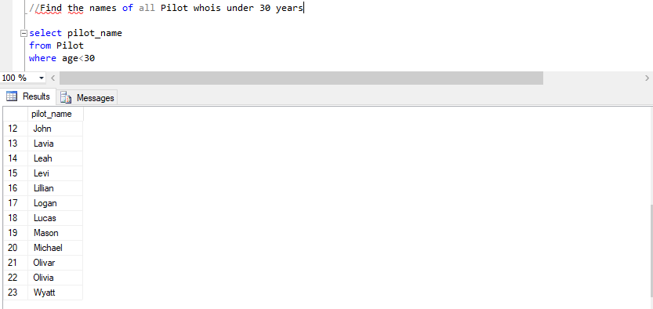

1. **Find the names of all passengers whose name includes the substring “Ma”**

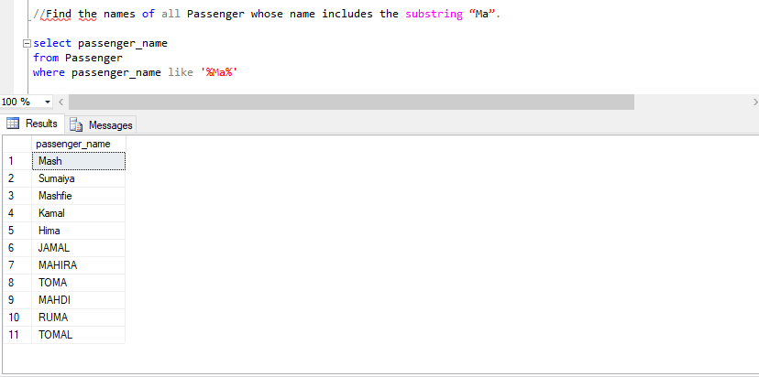

1. **List of the names of all plane in alphabetic ascending order**

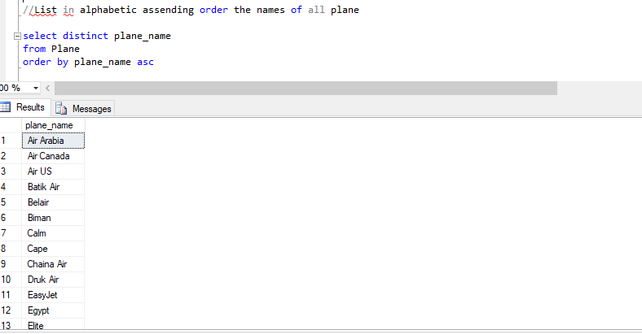

1. **Find the names of all plane with fare between $5000 and $7000**

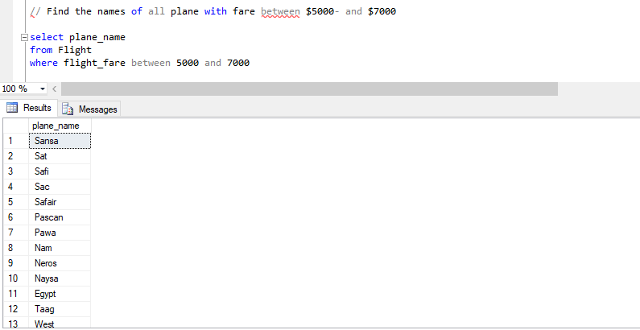

1. **Find the flight name of all flight that are less than the most expensive fare**

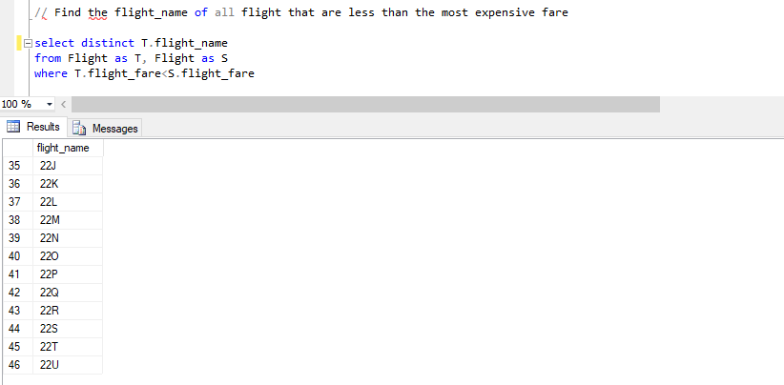

1. **Find all the fare of all flight**

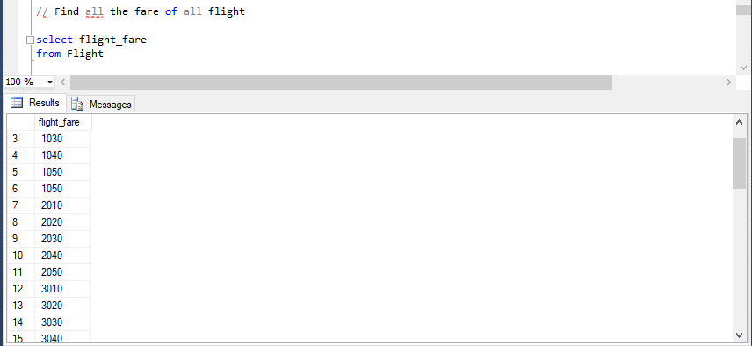

1. **Find the most expensive flight fare**

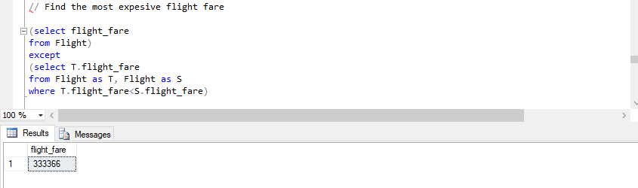

1. **Find the average fare of all flight**

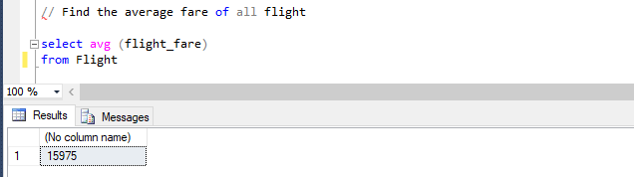

1. **Find the number of tuples in the ticket booking relation**

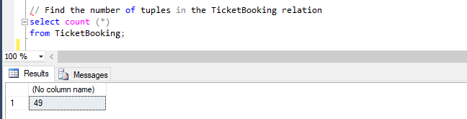

1. **Find average age of pilots**

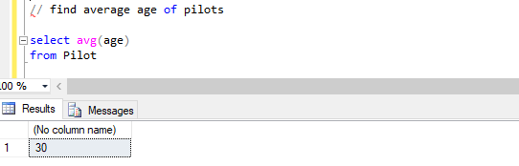

1. **Book a new ticket for Morshed (Insertion)**

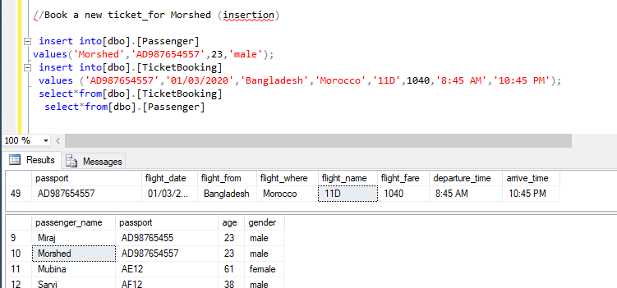

1. **Update a flight date (Update)**

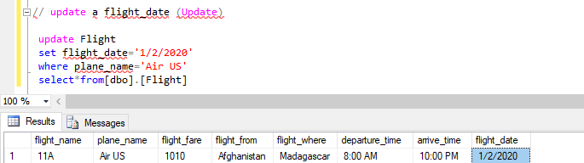

1. **Flight destination of “US Bangla” Plane**

